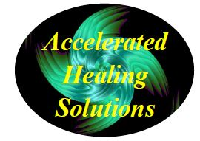
Dave Dodge, L.C.S.W.

Helping People Get Better Faster

128 Radio Circle Mt. Kisco, N.Y. 10549

www.AcceleratedHealingSolutions.com (914) 242-3484

_______________________________________________________________________________________________________________________________________

CANCELLATION POLICY

If you fail to cancel a scheduled appointment, the time cannot be used for another client and you will be billed for the entire cost of your missed appointment.

A full session fee session is charged for missed appointments or cancellations with less than a 24-hour notice unless it is due to illness or an emergency. A bill will be mailed directly to all clients who do not show up for or cancel an appointment.

Thank you for your consideration regarding this important matter.

_________________________________________________________________
Client Signature (Client’s Parent/Guardian if under 18)

________________________________
Today’s Date

