Dave Dodge, L.C.S.W.

Helping People Get Better Faster

128 Radio Circle Mt. Kisco, N.Y. 10549

dave@acceleratedhealingsolutions.com (914) 242-3484

www.AcceleratedHealingSolutions.com www.BrainspottingSpecialist.com
_______________________________________________________________________________________________________________________________________

The 31 Benefits of Gratitude You Didn’t Know About:

How Gratitude Can Change Your Life

by H H
_________________________________________________

Do you want more from your life? More happiness? Better health? Deeper relationships? Increased productivity?

Then have an Attitude of Gratitude

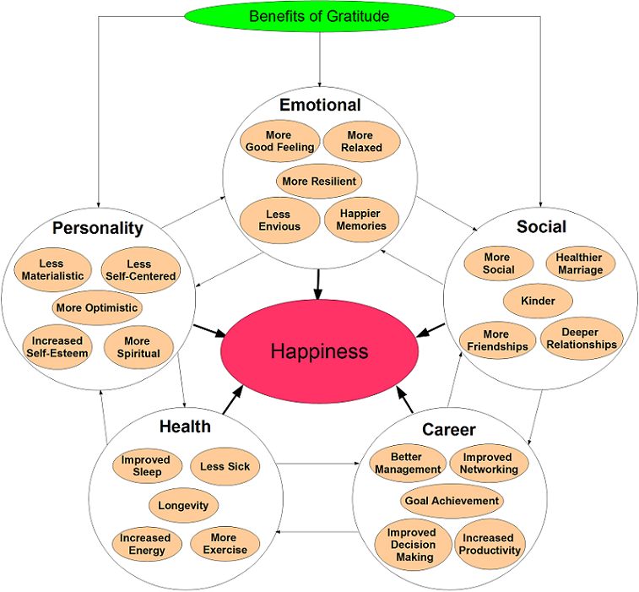
Seriously? All that? Yes. This list of benefits was compiled by aggregating the results of more than 40 research studies on gratitude.

1. Gratitude makes us happier.
A five-minute a day gratitude journal can increase your long-term well-being by more than 10 percent.^{a1,a2,a3} That’s the same impact as doubling your income!^{a4}
How can a free five minute activity compare? Gratitude improves our health, relationships, emotions, personality, and career.
Sure, having more money can be pretty awesome, but because of hedonic adaptation we quickly get used to it and stop having as much fun and happiness as we did at first.
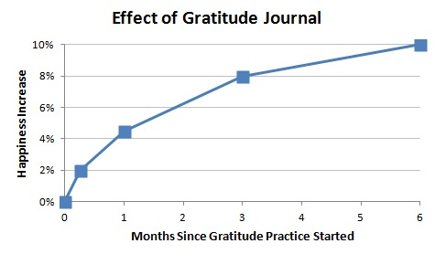
How can 5 minutes a day have such a large impact? (click to show)
Hedonic what?
Why does it take several months?

2. Gratitude makes people like us.
Gratitude generates social capital – in two studies with 243 total participants, those who were 10% more grateful than average had 17.5% more social capital.^{b1}
Gratitude makes us nicer, more trusting, more social, and more appreciative. As a result, it helps us make more friends, deepen our existing relationships, and improve our marriage.^{b2}
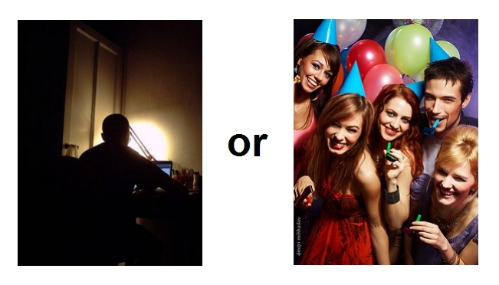

3. Gratitude makes us healthier.
Check it out:
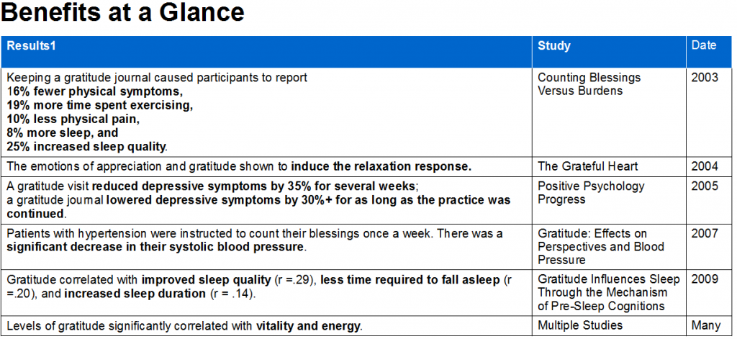
There is even reason to believe gratitude can extend your lifespan by a few months or even years.^{f2,f3,f4}

4. Gratitude boosts our career.
Gratitude makes you a more effective manager,^{c1,c2} helps you network, increases your decision making capabilities, increases your productivity, and helps you get mentors and proteges.^{b1} As a result, gratitude helps you achieve your career goals, as well as making your workplace a more friendly and enjoyable place to be.^{a2, b2}
Do you think this is effective?
http://www.youtube.com/watch?v=DlnObIFBCY4
I’m not suggesting that criticism and self-focus don’t have a place in the workplace, but I think we’re overdoing it.
65% of Americans didn’t receive recognition in the workplace last year.^{c3}

5. Gratitude strengthens our emotions.
Gratitude reduces feelings of envy, makes our memories happier, lets us experience good feelings, and helps us bounce back from stress.^{b2,d1,d2,d3}

6. Gratitude develops our personality.
It really does, and in potentially life-changing ways.^{a2,b2,d2,e1,e2}
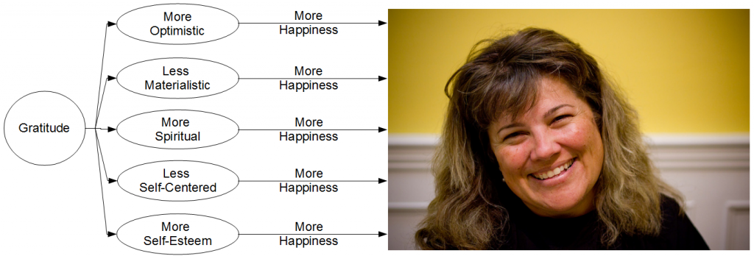
If you’re a man, don’t worry; gratitude won’t transform you into a woman.
Convinced of the benefits? Sign up for The Gratitude Hack, the course I created with the sole focus of helping you live a happier, more grateful life.
Not convinced? Want to know the details or explore the science that backs up these claims? Click below to go to the specific category or benefit that interests you, or just continue scrolling.
- Personality  - 7. More Optimistic  - 8. Less Materialistic  - 9. More Spiritual  - 10. Less Self-Centered  - 11. More Self-Esteem | - Health  - 12. Better Sleep  - 13. Keeps The Doctor Away  - 14 Longevity  - 15. More Energy  - 16. More Exercise | - Emotional  - 17. More Resilience  - 18. More Good Feeling  - 19. Happier Memories  - 20. Less Envy  - 21. More Relaxed

- Social  - 22. More Friendly  - 23. Better Marriage  - 24. More Respect  - 25. More Friends  - 26. Deeper Relationships | - Career  - 27. Better Management  - 28. Increased Networking  - 29. Goal Achievement  - 30. Improved Decision Making  - 31. Increased Productivity

7. Gratitude makes us more optimistic.
Gratitude is strongly correlated with optimism. Optimism in turn makes us happier, improves our health, and has been shown to increase lifespan by as much as a few years.^{f1,f2,f3,f4} I’d say a 5 minute a day gratitude journal would be worth it just for this benefit.
Show me the science. (click to show)
How does gratitude increase optimism? (click to show)

8. Gratitude reduces materialism.
Materialism is strongly correlated with reduced well-being and increased rates of mental disorder.^{g1}There’s nothing wrong with wanting more. The problem with materialism is that it makes people feel less competent, reduces feelings of relatedness and gratitude, reduces their ability to appreciate and enjoy the good in life, generates negative emotions, and makes them more self-centered.^{g1,g2,g3}
Why is materialism negatively correlated with happiness and well-being?
How does gratitude reduce materialism?
Will gratitude make me lazy?
Gratitude has caused me to focus less on things that don’t matter, like making money, and more on the things that do, like my family and this blog. I think that’s a good thing.

9. Gratitude increases spiritualism.
Spiritual transcendence is highly correlated with feelings of gratitude. That is – the more spiritual you are, the more likely you are to be grateful.
This is for two reasons:
- All major religions espouse gratitude as a virtue.^{h1}
- Spirituality spontaneously gives rise to grateful behavior.
I believe the opposite to also be true, that gratitude spontaneously gives rise to spiritual attribution, helping one feel closer to God or other religious entities. I am irreligious, and have found gratitude practices to make my spiritual position difficult – those moments when I feel intense gratitude make me want to believe in a benevolent God. My solution has been to re-direct my feelings towards Lady Luck.
Why does spirituality give rise to grateful behavior?

10. Gratitude makes us less self-centered.
I’ll be totally honest, I’m a self-centered twat. I’m a lot better now that I’ve brought gratitude into my life, but I still spend way too much time thinking about myself, and too little thinking about others. I expect this to change – because of my compassion and gratitude practices I am starting to have spontaneous urges to help others.
This is because the very nature of gratitude is to focus on others (on their acts of benevolence). In this regard, gratitude practice can be better than self-esteem therapy. Self-esteem therapy focuses the individual back on themselves: I’m smart, I look good, I can succeed, etc….
That can work, but it can also make us narcissistic or even back-fire and lower self-esteem.^{i1}

11. Gratitude increases self-esteem.
Imagine a world where no one helps you. Despite your asking and pleading, no one helps you.
Now imagine a world where many people help you all of the time for no other reason than that they like you. In which world do you think you would have more self-esteem? Gratitude helps to create a world like that.
How does gratitude create a more supportive social dynamic?

Health

12. Gratitude improves your sleep.
Gratitude increases sleep quality, reduces the time required to fall asleep, and increases sleep duration. Said differently, gratitude can help with insomnia.^{a2,j1}
The key is what’s on our minds as we’re trying to fall asleep. If it’s worries about the kids, or anxiety about work, the level of stress in our body will increase, reducing sleep quality, keeping us awake, and cutting our sleep short.
If it’s thinking about a few things we have to be grateful for today, it will induce the relaxation response, knock us out, and keep us that way.
Yes – gratitude is a (safe and free) sleep aid.
I don’t believe you!

13. Gratitude keeps you away from the doctor.
Gratitude can’t cure cancer (neither can positive-thinking), but it can strengthen your physiological functioning.
Positive emotion improves health. The details are complicated, but the overall picture is not – if you want to improve your health, improve your mind. This confidence comes from 137 research studies.
Gratitude is a positive emotion. It’s no far stretch that some of the benefits (e.g. better coping & management of terminal conditions like cancer and HIV,^{k1,k2} faster recovery from certain medical procedures, positive changes in immune system functioning,^{k3} more positive health behavior,^{k4,k5} etc…) apply to gratitude as well.
In fact, some recent science shows just that – those who engage in gratitude practices have been shown to feel less pain, go to the doctor less often, have lower blood pressure, and be less likely to develop a mental disorder.^{a1,a2,k6}
How does gratitude improve my health?

14. Gratitude lets you live longer.
I will be honest with you – by combining the results of a few different studies I’m confident that gratitude can extend lifespan, but no single study as yet has actually proven this claim.
Here is what we know: optimism and positive emotion in general have been used to successfully predict mortality decades later.^{f2,f3,f4} The optimistic lived a few years longer than the pessimistic. A few years may not sound like much, but I know when I’m about to die I’d like to have a few more years!
We also know that gratitude is strongly correlated with positive emotion. So, gratitude –> positive emotion –> an extra few months or years on earth. With positive psychology research on the rise, I believe we can expect this claim to be rigorously tested within the next five to ten years.

15. Gratitude increase your energy levels.
Gratitude and vitality are strongly correlated – the grateful are much more likely to report physical and mental vigor.
Show me the data.
Do people with more energy tend to experience more gratitude, does gratitude lead to increased energy, or is something else going on?

16. Gratitude makes you more likely to exercise.
In one 11-week study of 96 Americans, those who were instructed to keep a weekly gratitude journal exercised 40 minutes more per week than the control group.^{a2} No other study has yet to replicate these results. It could be because other gratitude studies testing this effect have been much shorter – in the range of one to three weeks, or it could be because this result was a fluke.
Once again, time will tell – but it would not surprise me if being grateful for one’s health would increase one’s tendency to want to protect it by exercising more.

17. Gratitude helps us bounce back.

Those that have more gratitude have a more pro-active coping style, are more likely to have and seek out social support in times of need, are less likely to develop PTSD, and are more likely to grow in times of stress.^{b1,b2,d1}
In others words, they are more resilient.

18. Gratitude makes us feel good.
Surprise, surprise: gratitude actually feels good. Yet only 20% of Americans rate gratitude as a positive and constructive emotion (compared to 50% of Europeans).^{l1}
According to gratitude researcher Robert Emmons, gratitude is just happiness that we recognize after-the fact to have been caused by the kindness of others. Gratitude doesn’t just make us happier, it is happiness in and of itself!
That’s no surprise – we idealize the illusion of self-sufficiency. Gratitude, pah! That’s for the weak.
F&ck no it’s not. Gratitude feels good, and if the benefits on this page are any indication – gratitude will make you stronger, healthier, and more successful.
Are you afraid to admit that luck, God, family members, friends, and/or strangers have and will continue to strongly influence your life? I once was – not only was I less happy, I was also weaker. It takes strength to admit to the truth of inter-dependency.

19. Gratitude makes our memories happier.

Our memories are not set in stone, like data stored on a hard-drive. There are dozens of ways our memories get changed over time – we remember things as being worse than they actually were, as being longer or shorter, people as being kinder or crueler, as being more or less interesting, and so on.

Experiencing gratitude in the present makes us more likely to remember positive memories,^{m1} and actually transforms some of our neutral or even negative memories into positive ones.^{m2} In one study, putting people into a grateful mood helped them find closure of upsetting open memories.^{m2} During these experiences, participants were more likely to recall positive aspects of the memory than usual, and some of the negative and neutral aspects were transformed into positives.

20. Gratitude reduces feelings of envy.

A small bit of jealousy or envy directed at the right target is motivating. Too much produces feelings of insecurity, materialism, inferiority, distrust, and unhappiness.

How does gratitude reduce feelings of envy?

21. Gratitude helps us relax.
Gratitude and positive emotion in general are among the strongest relaxants known to man. I was having trouble sleeping a few nights ago because I was too stressed and couldn’t relax. I’ll be honest, for the few minutes that I was able to hold feelings of gratitude I almost fell asleep, but holding feelings of gratitude is hard! In this case, too hard – I ended up getting out of bed.
Gratitude may be just as or even more effective than relaxation methods such as deep breathing, but because it is also more difficult, is unfeasible as an actual relaxation technique. Think of it like tea – one or two cups help you relax – three of four make you want to empty your bladder. But it could just be me. Perhaps you’ll find practices of gratitude more natural and easy.

22. Gratitude makes you friendlier.
Multiple studies have shown that gratitude induces pro-social behavior. Keeping a gratitude journal is enough to make you more likely to help others with their problems and makes you more likely to offer them emotional support.^{a2,b1}

23. Gratitude helps your marriage.
I’ve never been married, but from what I’ve heard, read, and seen, one way marriages start to suffer is that when the passion starts to fizzle, the partners become less appreciative and more naggy.
Scientists have put numbers to our intuition and experience, creating an appreciation to naggy ratio. More formally called the Losada ratio, it divides the total number of positive expressions (support, encouragement and appreciation) made during a typical interaction by the number of negative expressions (disapproval, sarcasm, and cynicism).
When the ratio was below .9, that is there were 11% more negative expressions than positive expressions, marriages plummeted towards divorce or languishment. Those marriages that lasted and were found satisfying were those with a positivity ratio above 5.1 (five positive expressions to each negative).^{s1}
Building regular practices of gratitude into your marriage is an easy but effective way of raising your positivity ratio.

24. Gratitude makes you look good.
Ingratitude is universally regarded with contempt. It’s opposite, gratitude, is considered a virtue in all major religions and most modern cultures. It may not be sexy to be grateful, but people will respect you for it.
Gratitude is not the same thing as indebtedness, which we rightly avoid. Indebtedness is a negative emotion which carries an assumption of repayment.
Gratitude is not the same thing as weakness. Weakness is flattery or subservience.
Gratitude is the acknowledgment of kindness with thanks.
It takes big balls to acknowledge that we didn’t get to where we are all on our own – that without others we may never have made it. That’s why, just maybe, gratitude may be sexy too.

25. Gratitude helps you make friends.
When I was in college I found it really easy to make new friends. If I hadn’t moved out of NYC it would still be easy – living in a farm town makes it difficult. I’ve found an effective way to start a conversation or move a relationship forward is an expression of gratitude, “thank you for that coffee, it was super delicious.” *wink, wink*
Ah, my mistake – that’s actually what I use to hit on my barista.
But you get the point.

26. Gratitude deepens friendships.
I have one friend who always deeply thanks me for taking the time to see her. That makes me feel appreciated and that makes me feel good. Wouldn’t it make you feel good too?

27. Gratitude makes you a more effective manager.
Effective management requires a toolbox of skills. Criticism comes all too easily to most, while the ability to feel gratitude and express praise is often lacking.
Timely, sincere, specific, behavior focused praise is often a more powerful method of influencing change than criticism. Specifically, multiple studies have found expressions of gratitude to be highly motivating, while expressions of criticism to be slightly de-motivating but providing more expectation clarification.^{t1,t2}
Contrary to expectation, if praise is moderate and behavior focused, repeat expressions of gratitude will not lose their impact, and employee performance will increase.²
Because of our culture, expressions of gratitude are often difficult to give – cultivating an attitude of gratitude will help.
I’ve seen firsthand the powerful difference between interacting with subordinates more with praise, and interacting with some more with criticism. Those I’ve given more praise are more enthusiastic about working with me, express more creativity, and are so much more fun to work with.
More Info: The Science of Praise: A Manager’s Guide To Giving Effective Employee Praise

28. Gratitude helps you network.
Gratitude has been shown across a number of studies to increase social behavior. Two longitudinal studies showed that those with higher levels of gratitude actually developed more social capital than those with lower levels.
Gratitude helps you get mentors, proteges, and benefactors.

29. Gratitude increases your goal achievement.
In one study, participants were asked to write down those goals which they wished to accomplish over the next two months. Those who were instructed to keep a gratitude journal reported more progress on achieving their goals at the end of the study. One result doesn’t make science – what you should take away from this is that, at the least, gratitude will not make you lazy and passive. It might even do the opposite!

30. Gratitude improves your decision making.
Decision making is really tiring – so tiring that we automate to our subconscious much of the reasoning that goes behind making a decision. Even for the most basic of decisions, like where to go eat, there are dozens of variables to consider: how much time and money do I want to spend, what cuisine would I like today, am I willing to travel far, what should I get once I get there, and so on. If you deliberated on each of these decisions one at a time, your mind would be overwhelmed.
The problem gets even worse for more complex decisions like making a diagnosis.
In one study, doctors were given a list of ailments from a hypothetical patient and also given a misleading piece of information—that the patient had been diagnosed at another hospital as having lupus. Half the doctors had gratitude evoked by giving them a token of appreciation. Those who did not receive a token of appreciation were more likely to stick with the incorrect diagnosis of lupus; those who did receive the gratitude were energized to expend more energy and to pay their gratitude forward onto their patient. They also considered a wider range of treatment options.
The above study shows that gratitude motivates improved decision making. Those who cultivate an attitude of gratitude find tokens of appreciation every day, on their own.

31. Gratitude increases your productivity.
Those who are insecure have difficulty focusing because many of their mental resources are tied up with their worries. On the other hand, those who are highly confident are able to be more productive, because they can direct more of their focus towards their work. This operates at both a conscious and subconscious level – we may be getting mentally distracted by our worries, or more commonly, parts of our subconscious mind are expending energy to suppress negative information and concerns.^{z1}
As gratitude has been shown to increase self-esteem and reduce insecurity, this means that it can help us focus and improve our productivity.
http://happierhuman.com/benefits-of-gratitude/

